RULE 1: FIELD MARKINGS
- The playing area will be marked with a solid lined rectangular boundary, 91.4 to 110 meters long between end lines and 55 to 60 meters wide between sidelines. Four cones may be used to mark the corners of the field. All field marking lines will be 5.1cm wide. It is recommended that all lines be painted white. No unauthorized marks or lines may be added to the field. A playing area of 110 x 60 meters will be used for WL events. (Rule 24).
- The playing area must be flat and free of stones, glass and protruding objects. The team bench sideline boundary must be 4 meters away from the scorer’s table. There must be 2 meters of space beyond the opposite sideline and spectators. There must be 2 to 4 meters of space beyond the end line boundaries and any natural or artificial objects, such as trees, bushes, athletic tracks, fences, spectators, or stands.
Guidance: Spectators must stay back at least 4m from the sidelines and are not allowed directly behind the team benches or score table. No spectators are allowed behind the end lines unless permanent seating is available.
- A goal line will be marked at each end of the field. The goal lines will be no less than 67.4 meters apart. The goal lines will be 1.83 meters in length and will be marked parallel to the end lines. (Rule 2)
- There must be 12 meters of playing space behind each goal line running the full width of the field. The 12 meters of playing space behind each goal line is measured from the back, outside edge of the goal line extended to the front, inside edge of the end line.
  - Two small circles 15cm in diameter must be added to the field behind each goal, 4 meters in from the boundary and 11 meters from the center of the goal line.
- Around each goal line, a goal circle will be marked. It will have a radius of 3 meters measured from the center back edge of the goal line to the outside edge of the goal circle. (Diagram 4)
- Restraining lines will be marked at each end of the field, 25 meters up field from each goal line. These solid lines will extend across the full width of the field. The 25 meters is measured from the back edge of the goal line to the front/midfield edge of the restraining line.
- In the center of the field, a center circle will be marked and have a radius of 9 meters when measured from the center of the circle to its outside edge. Through the center of this circle, a center line 3 meters in length will be marked parallel to the goal lines.
- Directions for marking the 11 Meter Advantage Flag Marking Area. (Diagram 2)
  - Locate D, a point on the center, back edge of the goal line. Using point D as the center, draw a circle with a radius of 3 meters measured from point D to the outside edge of the goal circle. Lightly mark lines AB and DB as shown.
  - Using point D as the center, lightly draw a semicircle with a radius of 11 m measured from point D to the outside edge of the semicircle. Mark point G (perpendicular to the center of the goal line at D).
  - Connect A to B and extend this line to the 11 meter semicircle. Mark point C on each side as shown. (Lines BC are at a 45° angle to the goal line extended; <EBC = 45°)
  - Draw a hash mark 31cm in length at point G. This hash mark will be perpendicular to the center of the goal line and bisected by the 11 meter semicircle at point G. Make 2 additional hash marks on the semicircle every 4 meters on each side of point G. There will be a total of 5 hash marks as shown.
  - At point H, 11 meters from the center of the goal circle on the goal line extended, draw 2 additional 15cm marks that are perpendicular to the goal line extended. (These marks are not hash marks but indicate where the 11 meter semicircle would intersect the goal line extended if the semicircle was drawn as a solid line.) This entire semicircle is called the “11 Meter Marking Area”.
  - Mark the curve of the arc with a solid line from C to C. Mark each side of the arc with a solid line from B to C.
7. Measurements:
A-G = 14.0m B-C = 8.65m D-H = 11.0m
A-C = 12.85m D-G = 11.0m
A-B = 4.2m D-C = 11.0m <HBC = 45º
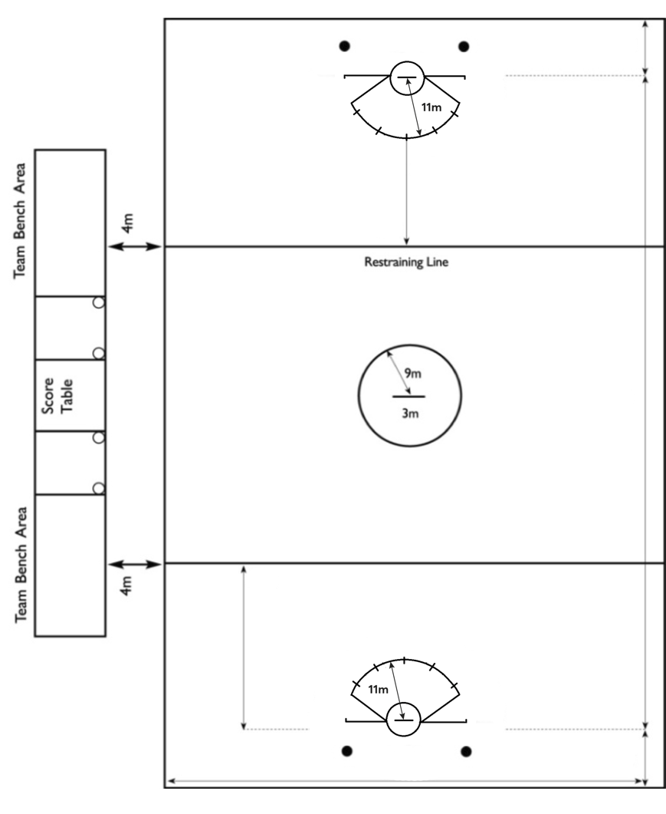
55 to 60m
25m
25m
12m
12m
91.4 to 110m
12m
Diagram 1 – Field Markings
Guidance: No additional marks may be added to the field.

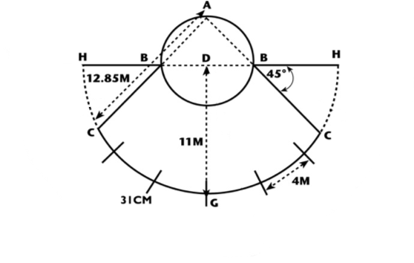

Diagram 2 – Directions for Marking the 11 Meter Advantage Flag Area
12m
- A scorer’s and timer’s table will be set at midfield in a marked 5 x 5 meters box that is set 4 meters outside the boundary on the teams’ bench side of the field.
Each team’s substitution area will be 4 x 5 meters and defined by two cones/markers placed 4 meters apart and even with the scorer’s/ timer’s table extended. Players must exit and enter the game through this gate area only. Players waiting to substitute must stand behind the markers and are the only team/bench personnel permitted in the substitution area. The coaches and other team bench personnel must remain outside the boundary, behind the level of the score table extended and inside the team bench area. The team bench areas will be 18.5 meters long and 5 meters deep.

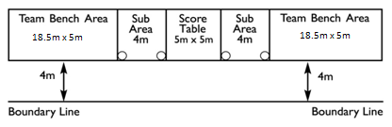
Diagram 3 – Scorer’s/Timer’s Table, Substitution Area & Team Bench Area
NOTE: Domestically, WL emerging and developing nations may choose to play the following modifications:
  - Teams may play on a smaller field; the goal lines will be 67.4 to 80 meters apart.
  - A full squad of 16 players.
For all WL Events, the official WL Women’s Rules will be played.

RULE 2: THE GOALS
- A goal cage will be placed in each goal circle.
- A goal cage consists of two vertical posts/pipes joined at the top by a rigid crossbar. The posts/pipes will be 1.83 meters apart and the top horizontal crossbar will be 1.83 meters from the ground. All measurements are inside measurements. The goal posts/pipes and crossbar will be 5.1cm square or 5.1cm in diameter and must be silver or painted white or orange.
  - If a freestanding goal is used, all ground, side and center back supports must be padded their entire length with material that limits the rebound of the ball. It is not necessary to pad goals with flat or angled ground supports that prevent the ball from rebounding off the supports into the playing area. No supporting braces should be placed in the corners of the goal that would prohibit a goal from being scored. (Diagram 5)
- Mesh cotton or nylon goal netting must not be larger than 4 cm. The goal net must be securely attached to the posts/pipes, the crossbar and to a point on the ground 2.1 meters behind the center of the goal line. The net should be strung to limit the rebound of the ball.
  - Any structure supporting the net behind the goal must allow the goalkeeper to move freely in the back part of the goal circle.
- The goal line will be drawn between the two goal post/pipes and must be continuous with them and the same width as the goal posts/pipes, 5.1cm (Rule 1.A)

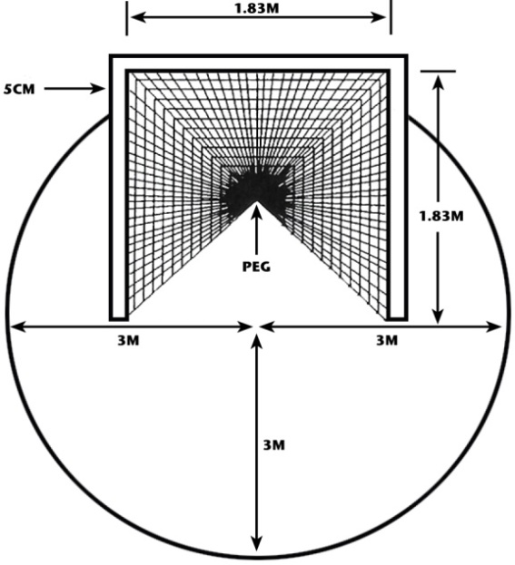
Diagram 4 – Goal Circle and Goal Cage Rule 2

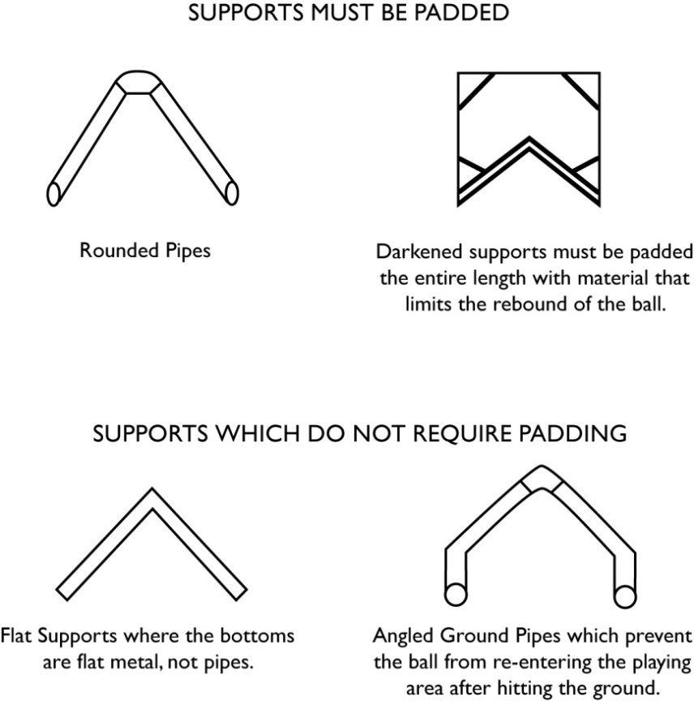
Diagram 5 – Goal Supports

