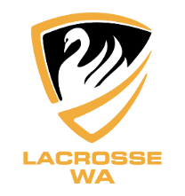
Assistant Coach – Selection Statement
LWA U15 Boy’s and Girl’s Regional Teams 2022 – Perth, West Australia
The information you provide will be treated confidentially and is important to establish an informed decision(s). Without this information, selectors may not be able to fairly assess your application. Once you have sent the document to the LWA Office it will be saved and can be used for future applications.
Please provide a paragraph or more responding to each of the key selection criteria/questions below.
Name:
- Outline any relevant coaching experience and successes:

- Outline the role(s) you wish to fulfil as an Assistant Coach:

- Outline your key skills, knowledge and abilities

- Outline how Lacrosse WA can best support you in this position:

- References – Please provide the details (name, email, mobile) of one player and one coach

Lacrosse WA is grateful for your commitment to our sport and your effort preparing this statement.

