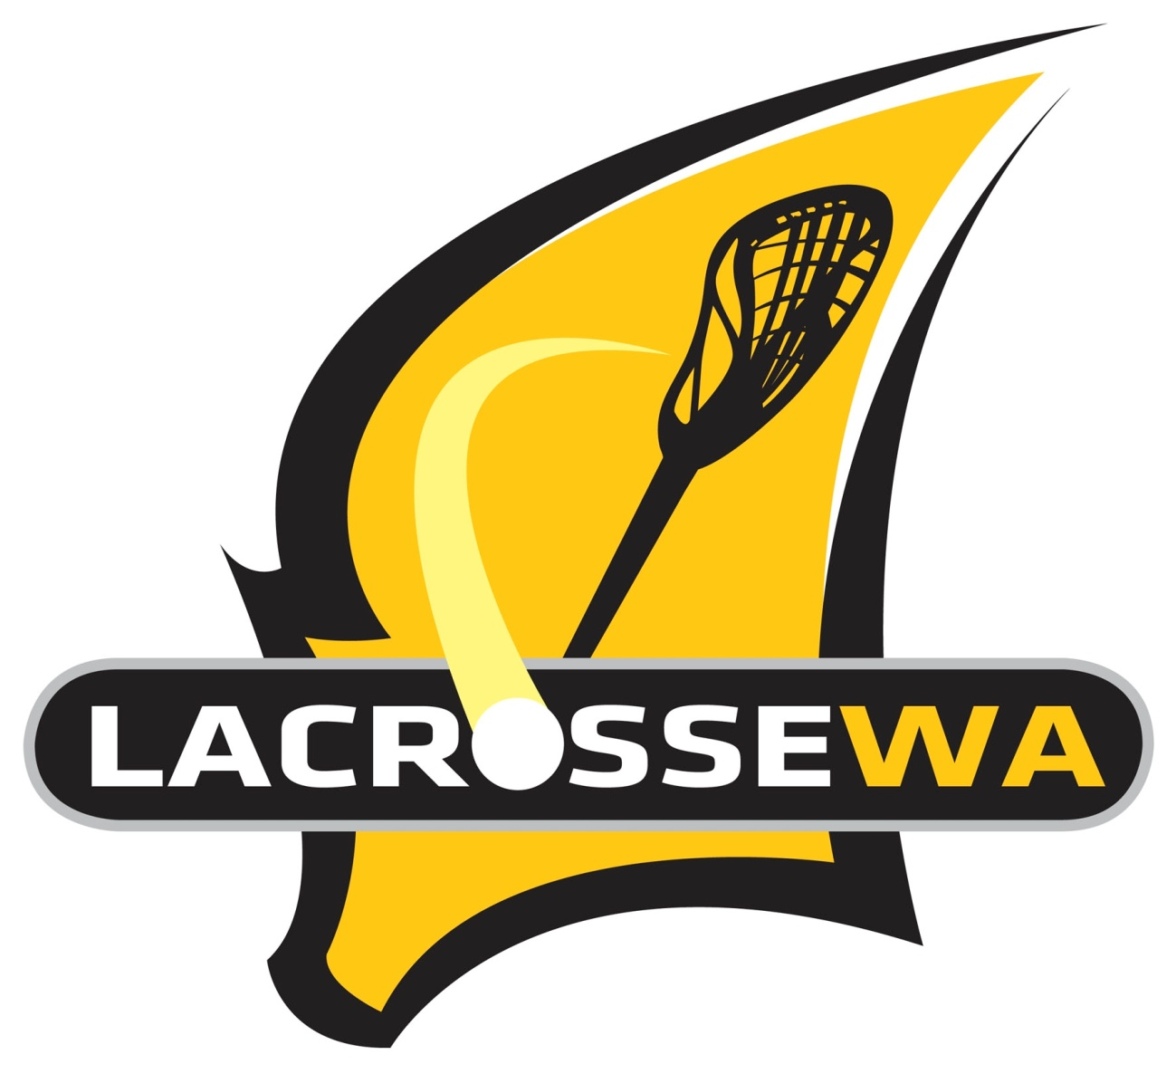
Head Coach – Selection Statement
LWA U18 Boy’s and Girl’s State Teams 2023 – Perth, West Australia
The information you provide will be treated confidentially and is important to establish an informed decision(s). Without this information, selectors may not be able to fairly assess your application. Once you have sent the document to the LWA Office it will be saved and can be used for future applications.
Please provide a paragraph or more responding to each of the key selection criteria/questions below.
Name:
- Outline any relevant coaching experience and successes:

- Outline any arrangements or structure you desire regarding team personnel positions and selections:

- Outline your desired team preparation calendar:

- Outline how you will attract a strong playing group to the program:

- Outline how you will conduct a fair and quantitative selection process:

- Outline a typical practice session you will conduct with the team:

- Outline a time when you were coaching and made change(s) that positively impacted the outcome:

- Outline any other important information:

- Outline how Lacrosse WA can best support you in this position:

- References – Please provide the details (name, email, mobile) of one player and one coach

Lacrosse WA is grateful for your commitment to our sport and your effort preparing this statement.

