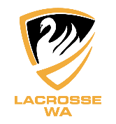
Team Manager – Selection Statement
LWA Men’s & Women’s State Teams 2023 – Adelaide, South Australia
The information you provide will be treated confidentially and is important to establish an informed decision(s). Without this information, selectors may not be able to fairly assess your application. Once you have sent the document to the LWA Office it will be saved and can be used for future applications.
Please provide a paragraph or more responding to each of the key selection criteria/questions below.
Name: _______________________________________________________________

- Outline any sports team management and sports administration experience:

- Outline any professional management experience and/or skills and attributes relevant to the role:

- Outline any further information relevant to your application:

- Outline how Lacrosse WA can best support you in this position:

- References – Please provide the details (name, email, mobile) of one player and one coach

Lacrosse WA is grateful for your commitment to our sport and your effort preparing this statement.

